1. Open in MATLAB TrajectoryGeneration.m which is in Scripts/MATLAB/ :
   1. Uncomment only your section!
   2. Make sure that only one trajectory is uncommented!
   3. RUN and wait for it to finish
2. Change the log file name:
   1. Go to Main Computer/
   2. Open CONFIG.py
   3. Change **MANUALLY** the name of desired Data file name:

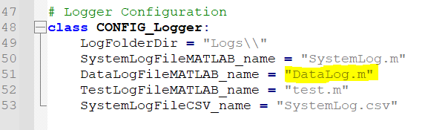

Add to “DataLog”the following string: “_section**%NO**_iter**%NO**” (replace “**%NO**” with the right number!!!)

For example it should be like:

“DataLog_section2_iter5.m”

1. Run the Main Computer by running Run_GS-and-GUI.bat
2. Put into the GUI the origin + stations positions and angles:

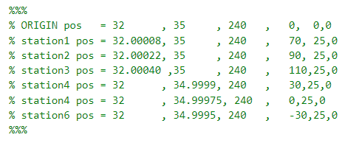

1. Run Run_Injector.bat and wait for it to finish
2. Press on the Main-Computer’s console and press Ctrl+C and enter (the computer will say it closed the files and then the window will close)

EAT  
SLEEP  
SIMULATE  
REPEAT